Encryption against surveillance & house raids
Threat model of this workshop: The police. Otherwise there would also be the Verfassungsschutz, BND, MAD, NSA, Google Amazon Facebook Apple Microsoft, criminal hackers, thieves, Nazi hackers, stalkers, abusive ex-partners, (potential) employers, job centres...

General safety tips:
1. Regularly install new security updates in which security gaps are closed.
2. Do not open any attachments that you do not trust.
3. Never use the same password twice.
4. Generate new passwords randomly; preferably with a password manager, e.g. KeepassXC.
KeepassXC files can be synchronised between devices using a cloud, for example. You can also request an ownCloud account at hextivisti-workshops@systemli.org.
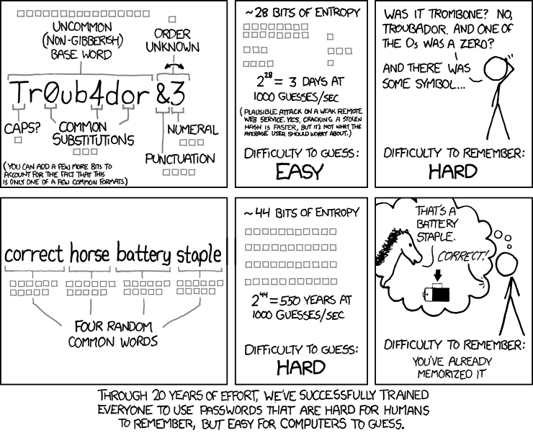

Hard drive encryption
System | Program / Method
from Android 10 / iOS | Set a screen lock code in the settings
until Android 10 | In Settings > Security > Encryption > Encrypt device  In den Einstellungen > Sicherheit > Verschlüsselung > Gerät verschlüsseln
Linux | Can be selected during installation for most Linux distributions (LUKS).
MacOS | In the MacOS settings (FileVault).
from Windows 10 | You can encrypt the system with Veracrypt, but make a backup beforehand.  Windows' own Bitlocker encryption is only useful with pre-boot authentication, and this is only available for Windows Professional/Enterprise. In addition, the recovery key is stored in the MS Cloud by default.
Single files | Cryptomator: Program for small encrypted safes(/vaults) that can be easily synchronised with the cloud
USB-Sticks | Veracrypt

Important to note for hard disk encryption:
As long as the files are decrypted (e.g. when the computer is running or on standby), the key is stored in RAM/working memory; so the first thing to do during a house raid is to switch off the computers and mobile phones.

E-Mail
Good: riseup.net, systemli.org, autistici.org – activist suppliers
okay-ish: posteo.de, mailbox.org, protonmail – Commercial providers with a privacy focus
bad: googlemail, hotmail, gmx, yahoo, yandex, …
Für systemli.org-Invites you can ask: hextivisti-workshops@systemli.org
End-to-end encryption: PGP. For this you need Thunderbird or Delta Chat, for example.

Messenger with end-to-end encryption
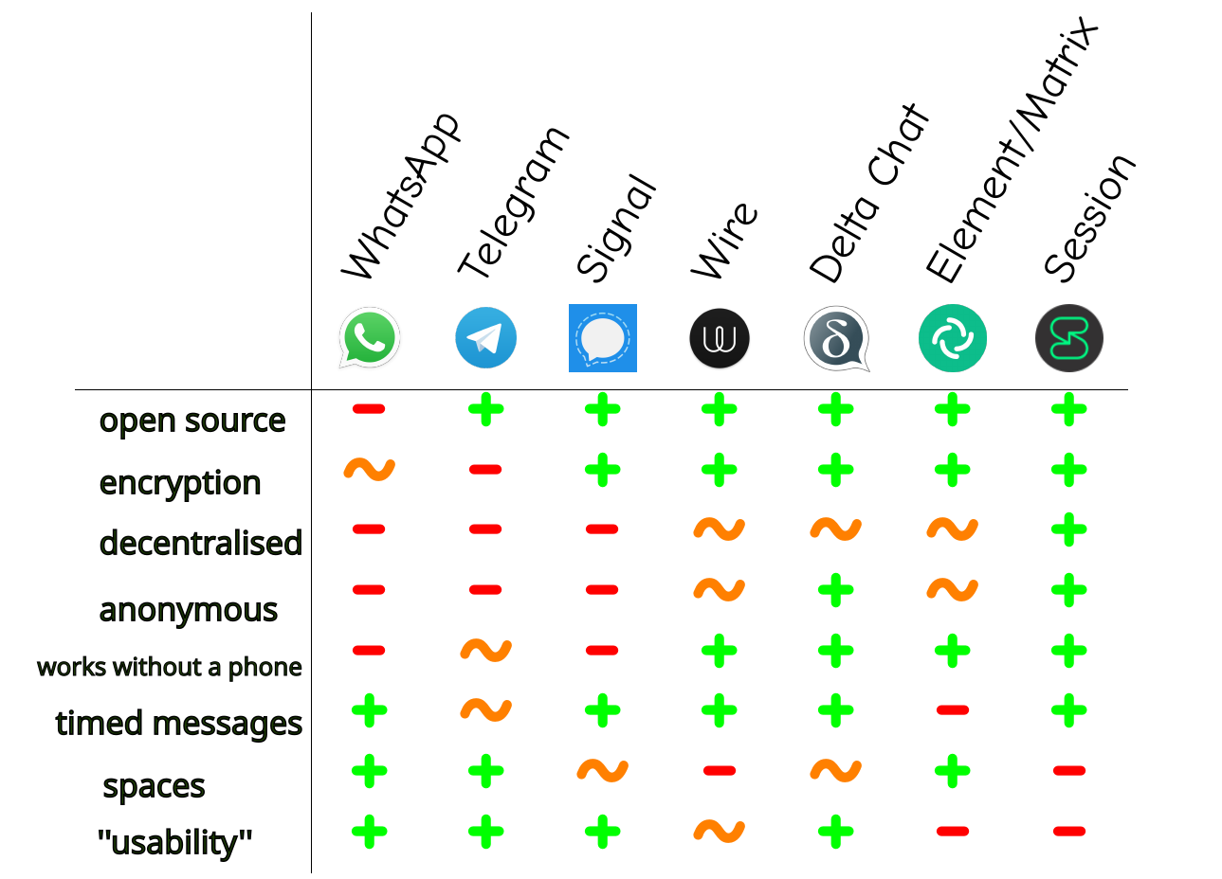
- Delta Chat - https://delta.chat
- Wire - https://app.wire.com
- Signal - https://www.signal.org

Tor-Browser
Online tracking is virtually unavoidable on most websites. Unless you use the Tor browser, which allows you to browse anonymously. But: don't log into different accounts at the same time if you don't want them to be associated with each other.

